**Robustness and extent of support for global redistribution,   
a survey in high-income countries**Pre-registration plan

Adrien Fabre; CNRS, CIRED

Abstract

The public support for internationally redistributive policies observed in previous surveys might have been overstated according to some hypotheses. A first hypothesis is that the salience of global issues in the surveys may have created a context favorable to universalistic answers; we address it with our tests H1 and H2. Second, while previous surveys have tested benchmark global policies, the support may be lower in the likely case where some countries do not participate, or if the policies deviate from the benchmark and are either more realistic or more radical (H3, H4). Third, a large part of the population might support a policy of global redistribution only for as long as its implementation seems unlikely, and the support might dissipate when the prospect of the policy materializes or if the policy can be replaced a less costly substitute with the same moral appeal (H5). To test these hypotheses, I will conduct a new representative survey over 12,000 respondents in the U.S., Japan, Russia, Saudi Arabia, and seven European countries.

**Survey structure**

I plan to launch one anonymous survey online in April to June 2025, on 11 countries. The median duration is estimated at 20 minutes. The intended sample sizes are as follows:

* U.S.: 3,000
* Japan: 2,000
* Russia: 1,000 (We are still unsure that we will be able to run a survey in Russia.)
* Saudi Arabia: 1,000
* Europe: 5,000, including:
  + France: 798
  + Germany: 1048
  + Italy: 756
  + Poland: 500
  + Spain: 603
  + Switzerland: 469
  + UK: 826

I will ensure representativeness of the samples using stratified quotas with the following strata: age (5 categories), gender (2), income (4), education (3; on the 25-64 population for all countries except Russia: the only country for which we found data on education for all adult population), degree of urbanization (2 or 3, except in Russia and Saudi Arabia where data is not available), as well as regions (2 to 5 depending on the country). I will add ethnicity (3) as a quota in the U.S., and citizenship (2) in Saudi Arabia.

I will define post-stratification weights and use these weights throughout the analysis. I will use two kinds of weights: the default weights will be based on the quota strata, and weights used for a robustness check will be based on quota strata and vote at the last election (I do not use the latter as default as people may lie to that question). Weights will be trimmed between 0.25 and 4 to avoid giving some respondents an excessive weight. I will exclude from the final sample respondents who fail the attention test or who rush through the survey (complete it in less than 6 min).

As I hypothesize that answers will be homogenous across European countries, to get better power in regressions, I will consider Europe as a block in the statistical analyses, weighing each country by its population.

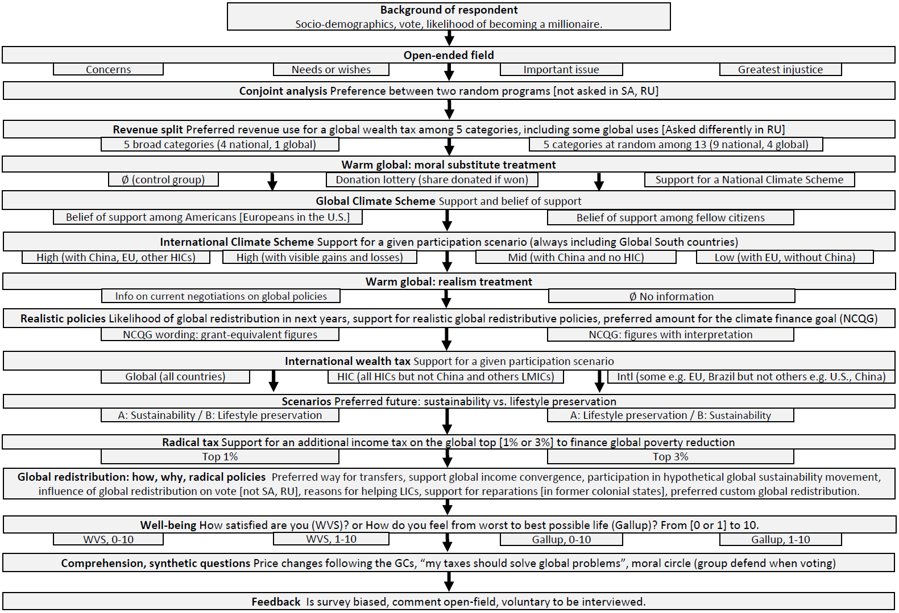

Figure 1. Survey flow

The questionnaire is uploaded to the repository. The survey’s structure will be as depicted in Figure 1, where underneath rectangles represent random branches. Randomizations are independent of each other and uniform (i.e. each branch is equally likely). When relevant, the survey randomizes the order of response items. The questionnaires are almost identical across countries. Deviations from the main questionnaire are the following:

* Some questions are not asked in certain countries where they are not relevant (e.g. vote is not asked in Russia nor Saudi Arabia; support for slavery/colonization reparations is only asked in former colonial or slave states: France, UK, Germany, Spain, Italy, U.S.).
* Some questions are asked differently in Russia as we cannot use the software Qualtrics as in the other countries. In particular, questions involving sliders are not asked.
* In many questions, figures (e.g. income brackets or tax revenues) and specificities of the questions (e.g. the country name or list of countries covered by a policy) are adapted to the country. Country-specific elements (including quotas) are specified in the file sources.xlsx.

**Hypotheses testing**

For each hypothesis, I will conduct as five tests, one per region: U.S., Europe, Japan, Russia, Saudi Arabia. As a complementary analysis, I will also conduct tests on subsamples (e.g. by individual European countries or by vote). I formulate my hypotheses mostly based on prior evidence from Fabre et al. (2025) in the U.S. and Western Europe. Absent prior evidence in other countries, I extend the hypotheses to the countries not covered by Fabre et al. (2025), even though one could expect less cosmopolitan answers in most of these countries. Indeed, Poland, Russia, Saudi Arabia are more conservative and poorer than Western Europe and the U.S., and it is unclear whether their population would support global policies.

In the following, the hypotheses are formulated in a colloquial way, which is the reverse of the null hypotheses of the one-way statistical t-tests that will be conducted (with the usual 5% threshold).

**H1: Global redistribution policies help a political program to be preferred**

The conjoint analysis asks respondents their preference between two political programs (they can also express indifference), with policies (or absence of policy) taken at random in each of five policy domains. The pool of policies has been manually chosen from the programs of the country’s main political parties, except for two policies of interest that are systematically added to the pool: “Cut development aid”, and “International tax on millionaires with 30% financing healthcare and education in low-income countries”. I improve upon Fabre et al. (2025) by including conservative policies in the pool of policies, and by including an anti-global redistribution policy (“Cut development aid”). Given prior results from Fabre et al. (2025) showing positive effects of global redistribution in most cases, I expect the following:

H1a: No positive effect of “Cut development aid” in the conjoint analysis.  
H1b: Positive effect of “International tax on millionaires with 30% financing healthcare and education in low-income countries” in the conjoint analysis.

**H2: Global issues are given substantial priority when allocating a budget**

Asked how to allocate the revenues from a global wealth tax, Fabre et al. (2025) shows that, on average, Europeans and Americans allocate one third to sustainable development in low-income countries. Some critics argue that the allocation would be lower if this global issue was not singled out. To test that, I ask respondents for their preferred allocation among five categories (there are two random branches: one where the five categories are fixed, one where they are taken at random out of 13 categories). As respondents have to split a budget between more items, it is expected that they will allocate less to each item than in the binary version by Fabre et al. (2025). However, I expect global issues to remain at a similar level of priority, substantial though lower than most national issues. Namely, I expect an average allocation at two thirds of the average amount, that is 13.33% (66.66% of 20%).

H2: Allocation of at least 13.33% of the budget to each global issue.

**H3: Global redistributive policies are supported by a majority**

I test the support for various global redistributive policies, from realistic ones to radical ones. Given the results by Fabre et al. (2025), I expect the realistic ones and the ones tested in Fabre et al. (2025) to garner majority support. Strong versions of H2 (H3c…) requires that radical policies be also supported by a majority. Given the results by Reichelmann & Hunt (2022) in the U.S., I expect (relative) majority opposition to reparations, so I do not formulate a hypothesis on this question. I assess the “majority” in a relative sense, excluding “indifferent” answers. When the questions are preceded by a treatment, the majority support is generally tested on the control group. I will also test an alternative specification where the control group is extended to treatment branches with no treatment effect (at a conservative 20% threshold).

H3a1, …, H3a10: Majority support for each realistic globally redistributive policy.   
H3b: Majority support for the Global Climate Scheme.   
H3c1, …, H3c9: Majority support for a global wealth tax, for a NCQG at least as high as the current amount ($26 billion in grant-equivalent), for a sustainable future, for both version a radical tax (on the global top 1% or top 3%), for global convergence in GDP per capita, for a global sustainability movement, for “my taxes should solve global problems”.

**H4: Lower support but still majority for international policies when fewer countries participate**

A limitation of Fabre et al. (2025) was to test the support for global policies, while it is unlikely that a policy be truly global, and the support could decrease if participation is non-universal. I expect support to significantly decrease with partial participation, though to remain in the relative majority.

H4a1, …, H4a6: Majority support for an international (non-global) wealth tax (two participation scenarios) and for an international climate scheme (four participation scenarios).   
H4b1, …, H4b6: Lower support for an international policy under partial participation.

**H5: Absence of warm glow**

A large part of the population might claim they support a policy of global redistribution just to ease their conscience. If support were mainly due to such a psychological mechanism, called warm glow, it might dissipate when the prospect of the policy materializes (H5a) or if the policy can be replaced a less costly substitute with the same moral appeal (H5b). To test whether people support global redistribution only for as long as its implementation seems unlikely, I randomly treat respondents with information about ongoing negotiations on globally redistributive policies. Following the information, I expect their belief that global redistribution is likely to be higher. Warm glow would be identified if the number of realistic global redistribution policies supported were then lower. I will test the effect of information on support both directly and through a two-stage least squares model, with the belief in likelihood of global redistribution as the endogenous variable. To test the effect of moral substitute, before the question on the support for the Global Climate Scheme, I randomly ask (or not) to the respondents how much they would like to donate to a reforestation charity, should they win the $100 lottery they are enrolled in. If the donation acts as a moral substitute, support should be lower for those who are offered this treatment.

H5a: Information increases the belief in the likelihood of global redistribution but does not reduce support for realistic global redistribution policies.   
H5b: Being offered the possibility to donate to a reforestation charity (in case of lottery win) does not reduce support for the Global Climate Scheme.

**Other analyses**

I do not detail the remaining analyses as they do not belong to the main research questions. They include the following exercises:

* Analyze the sociodemographic determinants of support for global redistribution.
* In the “custom redistribution” question, measure what proportion of respondents agree to the principles of global income redistribution, the proportion whose custom redistribution make them loser, and the preferred values for the minimal income.
* Analyze the occurrence of different topics in open-ended questions.
* Analyze which ways to transfer resources to low-income countries are preferred, and the reasons for wanting to help low-income countries.
* Analyze whether people underestimate the support for the Global Climate Scheme among Americans, and whether they believe Americans support it less than their fellow citizens (which are both expected).
* Analyze which policies are preferred in the conjoint analysis and in the revenue split.
* [For another project] Analyze the effect of wording on the answer to subjective well-being.

**Bibliography**

Fabre, A., Douenne, T., & Mattauch, L. (2025). Majority Support for Global Climate and Redistributive Policies. Nature Human Behaviour.

Reichelmann, A. V., & Hunt, M. O. (2022). White Americans’ Attitudes Toward Reparations for Slavery: Definitions and Determinants. Race and Social Problems, 14, 269–281.